Cassandra Assignment

Roll no.: 243514

Name: Dhruva Rakesh B

Date: 02/04/2024

Q1.

Create Employee table

1. Create table employee(

Empid int,

Emp_salary int,

Emp_lastname varchar,

Emp_firstname text,

Emp_dob date,

Emp_deptno int,

Emp_comm float,

Primary key((Empid,Emp_salary),Emp_firstname,emp_dob)

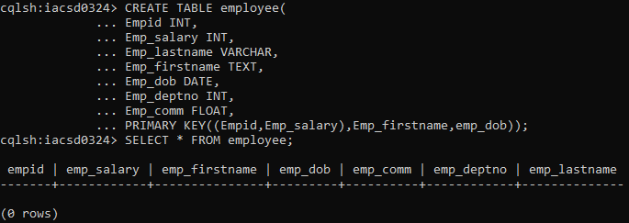

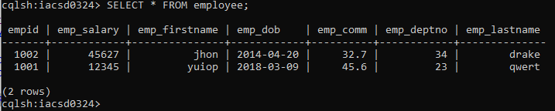

What is output of following query

* 1. Select * from employee Where empid in (1001,1002)





* 1. Select * from employee

Where empid=1001 and emp_dob=’1999-11-11’ and emp_salary=5000 and emp_firstname=’Rajan’

* 1. Select * from employee

Where empid=1001 and emp_dob=’1999-11-11’ and emp_salary>2000 and emp_firstname=’Rajan’

* 1. Select * from employee

Where empid=1001 and emp_dob=’1999-11-11’ and emp_salary>5000 and emp_salary<15000

* 1. Select * from employee

Where empid=1001 and emp_dob=’1999-11-11’ and emp_salary>5000 and emp_dept>10

* 1. Select * from employee

Where empid=1001 and emp_dob=’1999-11-11’ and emp_salary>5000 and emp_dept>10 ALLOW FILTERING;

1. Create table to store information about singer, use appropriate collections to store data Sid and name will be primary key

Sid integer, name string, store list of songs he/she sung, store list of music directors names and how many songs he sung with the director, store names of studios where recordings have been done and how many times recording has been done in the studio, also store movie, director name and song in the movie he/she sung.

* + - 1. Write query to add new director name and count 1 in the table
      2. List all records of ‘sonu nigam’
      3. Add new studio in ‘shan’ and ‘shreya’s list
      4. Perform batch operation to insert 2 records and delete 1 record from above table
      5. Delete list of studios and movies from above table from ‘shan’ and ‘sonu nigam’s record.

1. Create a data type to store information about server. For each server store id, name, ram capacity. Create a table lacation to store bldgname,floor number and list of servers on the floor. Building name is primary key and floor number is cluster key
   * 1. Find list of all servers from ‘A’ building and floor number > 5
     2. Find list of all servers from ‘A’,’B’,’C’ building.